Effectiveness of AR Visualizations In Computer Fundamentals Using Marker Based Tracking Technique

Zahir Khan¹, Ramish Masood², Adil Aijaz³, Qasim⁴, Mehjabeen Tahir⁵, Sidra Fatima⁶
^{1,2,3,4,5,6}Department of Computer Engineering, Sir Syed University of Engineering & Technology, Karachi, Pakistan, 75300
¹ce20-121@ssuet.edu.pk, ²ce20-086@ssuet.edu.pk , ³ce20-095@ssuet.edu.pk , ⁴ce20-113@ssuet.edu.pk
⁵matahir@ssuet.edu.pk, ⁶sfatima@ssuet.edu.pk

Abstract— In today's world, there are many different ways for people to get education and training in regards to specific information and skills that they need. These traditional methods mainly include classroom lectures with computers, books, notes, handheld devices, and other electronic appliances. The choice of learning innovation for an individual is dependent on one’s access to various technologies and the infrastructure environment of the surrounding community available. In a rapidly changing society where there is vast information and knowledge is available, adopting and applying that information in education sector at the right time and right place is needed to maintain quality of education. Augmented Reality (AR) is a technology that dramatically shifts the location and timing of learning and training. Our research paper describes how Augmented Reality, applies to learning in education specially in computer fundamentals course (it is a university course in which we selected computer hardware components and generated their 3D visualizations using AR). Our research provides solutions to challenges in traditional learning methods and shows how effective & economical AR visualizations can be in learning about computer hardware or components. This research compares the traditional learning methods with AR based learning approach applied to visualize computer hardware components in 3D showing how effective AR approach is against traditional learning methods. Our research aims to redefine the educational experiences through AR, enforcing more interactive and effective learning methods.

Keywords—Augmented reality, AR education, computer devices, Vuforia SDK, 3d models, marker tracking.

- Introduction
Augmented reality is an emerging technology in which the real world (RW) is enhanced by computer-generated content which is tied to specific locations and/or marker. In simple terms, AR mixes digital

content with the real-world objects and displays the mixed view result seamlessly into our perceptions of real world. Augmented reality (AR) refers to a wide spectrum of technologies that project computer generated materials, such as text, images, and videos, onto users’ perceptions of the real world.
Höllerer and Feiner (2004) explain AR systems as system which is combination of “real and computer-generated information in a real environment, interactively and in real time, and [which align] virtual objects with physical ones” (p.2) [1]. Ludwig and Reimann (2005) define AR as “human-computer-interaction, which adds virtual objects to real senses that are provided by a video camera in real time” (p. 4) [2]. Zhou, Duh, and Billinghurst (2008) define AR simply as technology “which allows computer generated virtual imagery to exactly overlay physical objects in real time” (p. 193) [3].
Apart from 2D and 3D objects, digital content such as audio, video files, and texts can also be mixed with the real-world objects and then displayed together in our perceptions of real world. The combined mixed view consisting of real & virtual objects will enhance the user’s knowledge effectively.
There are four types of reality environments. First is the real world i.e. that is the world we live in. As the opposite of this, there are virtual worlds, or virtual environments (often labeled virtual reality), in which all information that is perceived by individual is computer-generated and there is no relation to real world locations, objects, or activities. Between these two types of environments, there are two types of augmented environments:
Augmented Reality (AR) which takes the real-world content and real environments as its backdrop view and inserts computer-generated content, and 2nd is augmented virtuality, in which computer-generated world becomes the backdrop while real-world data is blended in and superimposed. Below figure (fig.1) illustrates the mixed reality (MR) spectrum, or the Reality-Virtuality (RV) Continuum, proposed by Milgram et al. (1994).
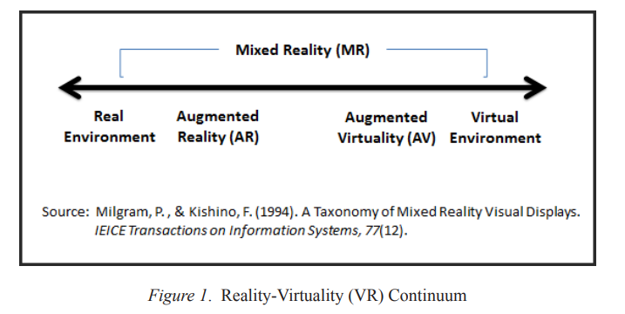

Fig. 1: Four types of reality environments.
As the world advances day by day, more and more hardware components are being introduced each day. In this technological era, students demand interactive and engaging methods of receiving education especially in the field of computer engineering where students have to learn about hardware components. Traditional learning methods that have been used from centuries, have become less interactive and engaging for students in today’s distracting environment of the world. Static images, books, pdfs tend to make students lose their interest in the subject. Most computer engineering students doesn’t have physical access to internal components of computer in most of the higher educational institutions. They are just provided with static learning material which results in students losing the interest in the subject, hence causing degradation of the grades.
In this research paper, we have proposed an AR solution “AR-CF Application” for students which solves many of the problems stated above. AR is a technology that can change the future of education especially in the field of computer engineering. Our research paper shows how effective AR visualizations can be in learning computer fundamentals especially hardware concepts as compared to traditional learning methods. This research shows clear difference between the traditional learning methods and AR learning approach using marker-based technique. A comparison between traditional methods and AR learning approach is also made in this research paper. To compare these two learning approaches, we took some quizzes from students and results of these quizzes clearly show that AR visualizations play an important role in developing and increasing students interests in computer fundamentals course by creating interactive and engaging virtual learning experiences for students. Our AR solution provides students with access to hardware components virtually anywhere, anytime at no cost. This research strives to bridge the gap between theoretical understanding and practical application of computer concepts thus providing interactive and engaging learning environment for computer engineering students.

- Literature Review
- Advancement Of Cameras & Sensors:
Ozlem D claims that everyday users would benefit from gadgets with advanced features and substantial processing capacity, such as activity detection [4]. According to Muhammad S., movement and activity detection is accomplished through the synchronized operation of the gyroscope and accelerometer [4]. It’s the responsibility to track the rotation or direction of the angle by rotating the device’s Gyroscope and Accelerometer to detect acceleration or sense the device’s vibration [5]. With the help of advanced smartphone devices and sensors like cameras, a Specific accelerometer and gyroscope are used in the augmentation world, which were created with the help of real-world information and is also important for creating an AR-based application.

- Related Research:
The work of Sasa Cukovic and his colleagues [6] highlights the application of AR in the medical field, specifically visualizing 3D foot models. They have implemented marker tracking for implementing augmentation which overlays 3d biomedical models on the real environment and physicians and students can benefit from it. Marker-based tracking using UbiTrack and for rendering unity is used to enhance the understanding of 3D structures of foot in anatomy. Another student of Electronics and Communication Engineering Department PES University, Bangalore is Pooja J et al. [7] who contributed to the literature with a focus on augmented reality in education, particularly in the online learning environment. The authors discuss in their research about the integration of AR for subjects like Engineering Mathematics and Electromagnetism. Their approach involves both marker-based and marker-less AR methods, with a detailed exploration of homography estimation using RANSAC. The development of an Android application utilizing Unity3D and Vuforia SDK showcases the potential for AR to revolutionize remote education. This work highlights the versatility of AR in bringing 3D models into the real world to aid in understanding complex concepts. Siti Sendari et al.'s research [8] focuses on the application of augmented reality in introducing hardware components to users. The proposed system, developed using Unity3D and Vuforia SDK, aims to educate users about computer hardware through AR technology. The authors conduct a comprehensive analysis of the system's performance in detecting hardware components based on factors such as light intensity, distance, and camera angle.
- Gaps In the Previous Researches:
Research | Gaps in Previous Researches
[6] | Image target is made of  black square with a white  border of a predefined size. ID is encoded in the black square.
[8] | Augmentation of only text is done. Image input is given and based on that only text is displayed.

As comparison to Marker Based vs. Natural Feature Tracking Augmented Reality Visualization of the 3D Foot Phantom [6], in our project, Image targets are made of unique letters and colors which give more identification points and image targets are easily uniquely identified. Similarly, in comparison with Augmented Reality Performance in Detecting Hardware Components Using Marker Based Tracking Method (2020) [8], in our project, the augmentation of 3D Models is done which is more interactive & engaging for students as compared to visualization of only text.

- Methodology
Vuforia Engine:
Vuforia is the most widely used platform to develop rich, immersive AR applications with robust tracking and a proven performance. Vuforia Engine provides a handy SDK for those looking to develop an AR application platform. It is one of the most popular AR software tools, known for its advanced computer vision, calibrated performance and cross-platform reach. The SDK incorporates a marker-based AR system in which the markers are the images or 3D objects registered with the application using the Vuforia library. It acts as information triggers in your application. Developers can easily add advanced computer vision functionality to any AR application, allowing it to recognize images and objects, and interact with spaces in the real world. Developers can put AR content on flat objects, cylindrical targets, flat surfaces with multiple sides, and conical shapes.
Tracking:
Vuforia tracking algorithms utilize some variation of natural feature tracking. Natural features in images are usually sharp details such as high contrast corners or the tips of the image target. The technique was introduced in the early 1980s and revolves around splitting an image into several sections. Each section is shifted in several directions and the change in image intensity (RGB value) is measured. For instance, if a section of an image contains a straight line – or edge, as it is more commonly called – a shift along the edge will result in small overall changes in image intensity. However, a shift perpendicular to the edge will cause large changes. A corner, or spot will cause large changes when shifted in any direction. By considering these changes in image intensity, the feature tracking algorithm can determine what is a feature and map the positions of these features in the image [9]. As a result, the algorithm creates a pattern of features. In Vuforia, this pattern of features is what define a target. When the target is detected by the application, the features are matched against pre-defined feature patterns and the pose of that target is estimated [10]. Pose is a common term used in the area of computer vision. It is the combination of position and orientation, often in relation to a 2D coordinate system. In Vuforia’s case, the coordinate system is made up of the pattern created by the natural feature tracking.
The basic methodology of “AR based Computer Fundamentals Course App” is shown in fig 3.1: 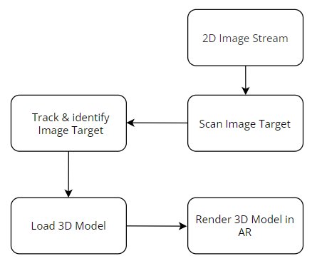
Fig. 3.1: Methodology of AR based Computer Fundamentals App
Targets:
A target is a pattern of natural features pre-defined by the developer or user. In other words, if the Vuforia tracker is to find a certain image, or object, the software needs to know what patterns to look for. For this purpose, developers can use Vuforia’s Target Manager. Vuforia offer developers a web service to create targets from 2D images, cuboids, cylinders and 3D objects.
Extended Tracking:
Extended tracking is a feature that allows Vuforia to track targets using natural features surrounding it. With these natural features Vuforia is able build a map of features surrounding the target and maintaining detection even though it is not within the camera view. With extended tracking enabled, Vuforia may track targets even when the associated target is out of view.
Image Recognition:
Using the Target Manager, we can define an image target by using any image of choice. Whether the image makes a good target is another question. The composition and number of features are the deciding factors in how easily Vuforia can detect an image target. For instance, the image targets shown in fig 3.2 demonstrates what Vuforia considers a “good” target.
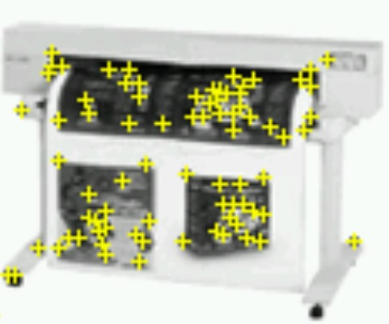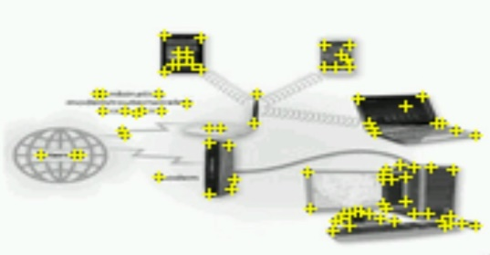
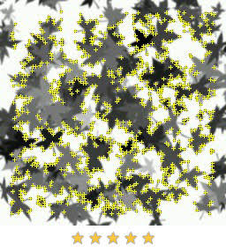
Fig. 3.2: Examples of Highly detectable Image targets
As seen in fig. 3.2, the detection points are in great number which makes it easier to detect the image target. More specifically, good targets contain a higher number of features arranged as uniquely as possible. A picture of a dense 2D grid might contain many features, but as the pattern is very repetitive, every section of that image will be indistinguishable by Vuforia. This makes it impossible for the software to determine what is up, down, left or right thus making such images as bad targets [11]. Images of round shapes without sharp edges would also make bad targets, simply because there are no features for Vuforia to detect as shown in fig. 3.3.

Fig. 3.3: Images of circular shapes makes for bad targets. Observe the complete lack of features (no yellow crosses).
All three image targets are augmented with text informing the user if the image was detected. An augmentation will only appear if the image target is detected. The image targets in fig. 3.2 are detected immediately due to their high grade of detectability whereas the black circle in fig. 3.3 is not detected at all due to its circular shape (lack of detection points) and black color.
Algorithms:
Marker Detection Algorithm:
Step 1: Initialize the camera and set up marker tracking.
Step 2: Continuously capture frames from the mobile / device camera.
Step 3: Use computer vision techniques to detect and track predefined markers (e.g., image targets) in each frame.
Step 4: If a marker is detected, then calculate its pose (position and orientation) relative to the camera.
Else step 2

User Interaction Algorithm:
Step 1: Implement gesture recognition to allow users to interact with the 3D models. Common gestures include:
- Pinch-to-zoom for scaling.
- Rotate gestures for changing the view angle.
Step 2: Capture and process user input from touch, gestures.
Step 3: Translate user actions into corresponding interactions (rotate, zoom in or out) with the AR scene.

- Experiments And Results
- Marker Based Augmented Reality Approach:

When the image target is brought in front of camera, the corresponding 3D model is shown over the image target as shown below in fig. 4.1:

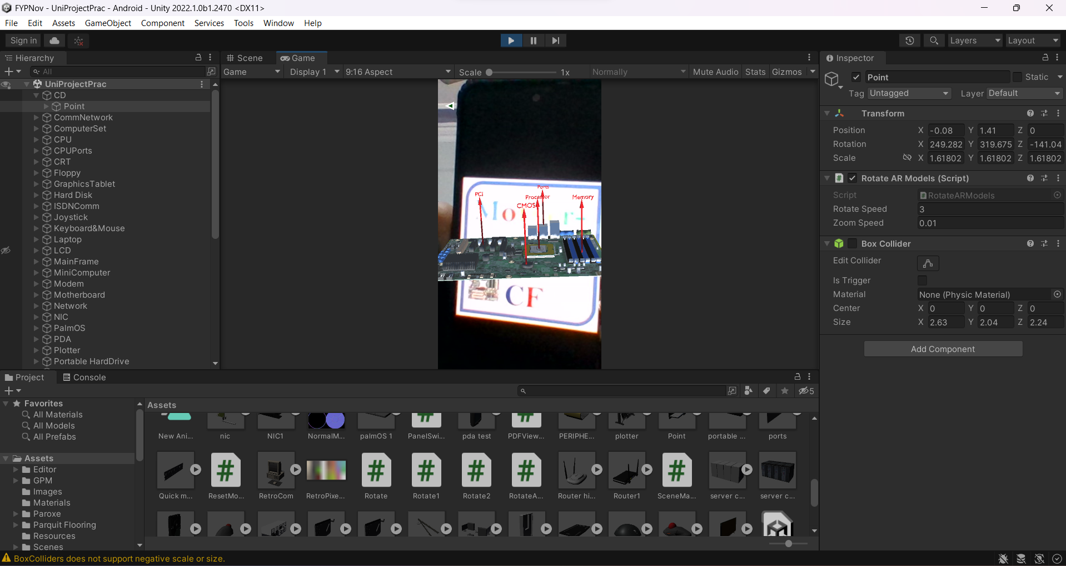

Fig. 4.1: 3D model shown on the screen when image target is detected and correctly identified.
This is the marker-based augmentation in which 3D model is displayed over the image target when image target is detected & identified. The 3D model now can be visualized, rotated and zoomed in or out based on fingers gestures.

- Application Development:
In order to create high quality 3D models, we used Blender. Blender is a free and open-source 3D computer graphics software tool set used for creating animated films, visual effects, art, 3D-printed models, motion graphics, interactive 3D applications, virtual reality, and, formerly, video games. Blender's features include 3D modelling, UV mapping, texturing, digital drawing, etc. We built computer components 3D models using Blender.
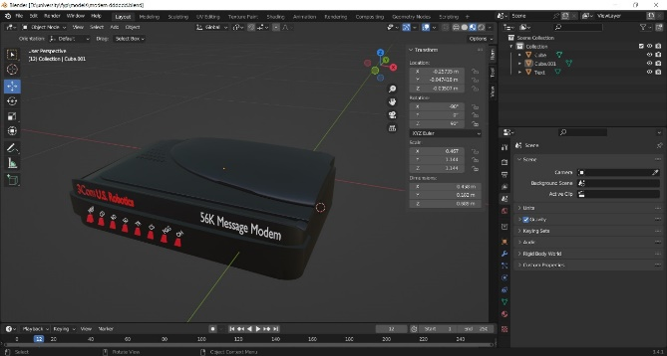
Fig. 4.2: 3D Model of Modem designed in Blender.

These models were imported in Unity environment where we implemented C# scripts. Vuforia Image tracking is used for tracking Image targets. The image target is tracked and scanned and then respective 3d model will be shown on the screen.
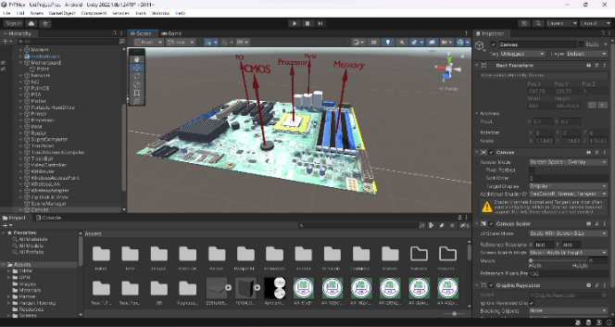
Fig. 4.3: 3D Model of CPU Motherboard imported in Unity Environment.
The application development is done on Unity 3D for the ease of integration of 3D models, image target identification mechanism (Vuforia target manager) and app’s UI. Unity3D is a great tool for developing AR applications which provides many options including designing responsive UI, writing C# scripts, applying different textures on imported 3D models and implementing Vuforia AR SDK in the AR application.

- Testing of Image Targets:
We tested our image targets thoroughly and found accuracy of our system. Correct Identification of image targets is important because, if wrong image target is identified, then wrong 3D Model would be displayed on the screen. We tested Identification of Image targets for almost 120 times. Here’s the result we got:

Total Tests = 120
Correct Identifications = 112
Incorrect Identifications = 8
So,
Accuracy = (112 / 120) * 100
Accuracy = 93.3%

Graphical Representation:
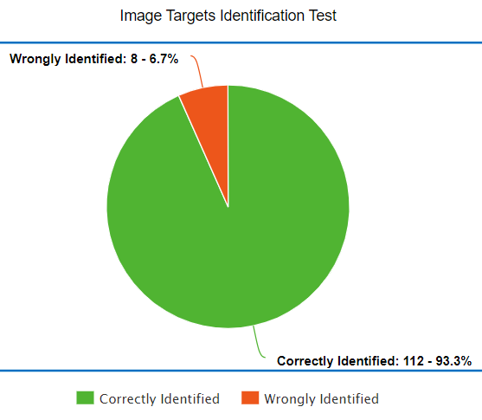
Fig 4.4: Image targets correctly identified vs wrongly identified using device camera.

As can be seen from the above results and from the graphical representation, the accuracy of our system is about 93.3%. We conducted 120 tests and out of 120 tests, 113 times the image target was correctly identified. The accuracy that we achieved in our system is important because if the accuracy is less than 70%, then the students will not be satisfied with our AR app as chances of misidentification of image targets will increase which in turn will display wrong 3d models on screen.
Overall, these findings show the effectiveness and reliability of our system in accurately recognizing image targets, hence enhancing the user experience and ensuring that the application will run smoothly.
- App Feedback from Students:
We took 2 short quizzes from 60 students who were studying computer fundamentals course in order to find efficiency & get feedback of our App. Each quiz consisted of 20 MCQ’s (1 mark each). These quizzes were designed to evaluate the effectiveness of our AR App. The students were divided into two groups: Traditional group and Experimental group and each group had 30 students. 2 quizzes were taken from both groups separately. 1st Quiz was taken without providing any learning content to the students. For 2nd quiz, we provided them learning content, and let them get prepared for quiz and then quiz 2 was taken.
For 2nd quiz, traditional students’ group were provided with only traditional methods of learning i.e. like lectures & pdfs whereas Experimental group students were provided with our App installed in their mobile phones along with traditional content too. Our app provided them an interactive platform to visualize and interact with the computer components in 3D. The students were also provided with updated PDF lectures that contained Image Targets of the 3D models; they were instructed to scan those image targets to visualize the 3D models.
This is the result that we got from our quizzes:
- Quiz 1:
Quiz 1 was taken without providing any learning material to students. Quiz 1 was taken without any preparation of students. This is the result that we got from quiz 1:
Traditional Group:
Mean Score = 10.933 out of 20,
Standard Deviation = 1.162
Experimental Group:
Mean Score = 11.33 / 20,
Standard Deviation = 1.397

As you can see from the results that quiz 1 yielded almost same results for both groups as no learning content were provided to the students of both groups.

- Quiz 2:
Quiz 2 was taken after providing students with the learning material (Traditional group with pdfs, lectures and Experimental group with pdfs, lectures & our App), this is the result that we got from quiz 2:
Traditional Group:
Mean Score = 13.2 out of 20,
Standard Deviation = 1.373
Experimental Group:
Mean Score = 16.06 out of 20,
Standard Deviation = 1.279

As you can see from the results that in quiz 2, traditional group students scored better (mean score of 13.2/20) as compared to quiz 1 but they scored less than the experimental group students (quiz 2) which have mean score of 16.06/20.

- Tabular Representation of Results:
 | Traditional Group  (Mean Score out of 20) | Experimental Group  (Mean Score  out of 20)
Quiz 1  (No learning content provided) | 10.933 | 11.33
Quiz 2 (Learning Content provided) | 13.2 | 16.06

Table 4.1: Quiz results of Traditional Group vs Experimental Group Students.

- Graphical Representation of Results:
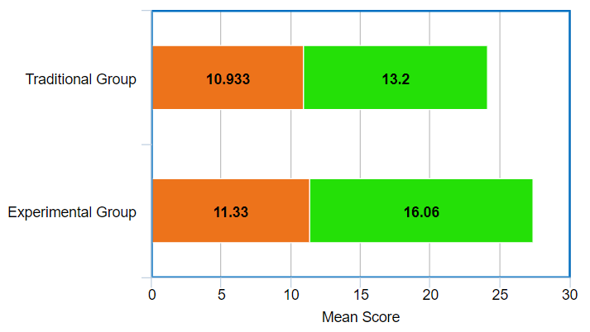
Fig 4.5: Quiz results of Traditional Group vs Experimental Group Students.

It can be clearly seen that the difference in the marks of quiz 1 and quiz 2 for experimental group students is bigger (mean difference = 4.73) than that of students of traditional group (mean difference = 2.267). This means that Experimental group students learning method was more effective as compared to traditional group students.
Due to the attractive visualizations of the 3d models in our App, the Experimental group students showed more interest in the subject asking more questions from us as compared to the traditional group.
The students of Experimental Group also provided us with their feedback about their overall experience using our App. They also provided us with recommendations on how to enhance the UI design of our application. Also, the students were really pleased when they came to know that this App is totally free of cost.

- Conclusion & Future Work
In this research, the effectiveness of Augmented Reality learning approach is evaluated by visualizing computer components in 3d and a comparision is made between traditional learning methods and AR based learning approach for students. Through the students quizzes result, it can be clearly seen that the AR learning approach which enforces visualization in learning is much better than the traditional learning methods as experimental group students scored better than traditional group students. The difference is clearly visible using the graphical representations. This is because visualizations of any sort are naturally appealing to human beings, so here too, for students who studied by our provided App (consist of 3d components AR visualizations) along with books and pdfs too, find it more engaging and interesting, hence scoring more as compared to students who were provided with traditional learning methods which include only books, pdfs, slides. The image target identification tests show that the accuracy of our system is 93.3% meaning that 93.3% of times, the correct image target is detected which will ensure in displaying correct 3d model on the device screen.
As of now, we have implemented AR on only computer components that students can interact with and, we have also put animations on some models that run automatically. In future, more animation controls can be incorporated into these 3d models for even better visualization, interactivity & sense of control. Further, this research is done on only computer components, so in future, the whole computer fundamentals course including static content, theory, and many more content can be adapted using this AR approach which will provide students with even more options of engagement and interactivity with course material. There will be less need of books, students would just open the app and start studying from there as the entire lecture would be available as AR content in the App as text can be easily incorporated with AR 3D models in the application.
- Acknowledgement

We would like to sincerely thank the teaching staff of the Computer Engineering department and also the University staff for giving us an opportunity to work on this project and giving us constant guidance during this research.

- References
[1] Höllerer, T. H., & Feiner, S. K. (2004). Mobile Augmented Reality. In H. A. Karimi, & A. Hammad (Eds.), Tele geoinformatics: Location-Based Computing and Services, (pp. 392-421). CRC Press. Hughes, C. E., Stapleton, C
[2] Ludwig, C., & Reimann, C. (2005). Augmented reality: Information at focus. Cooperative Computing & Communication Laboratory (Volume 4. No. 1). Universität Paderborn.
[3] Zhou, F., Duh, H.-L., & Billinghurst, M. (2008). Trends in augmented reality teaching, interaction and display: A review of ten years in ISMAR. Mixed and Augmented Reality, ISMAR 7th IEE/ACM International Symposium pp. 193-202. Cambridge: IEEE.
[4] Ozlem Durmaz Incel, Mustafa Kose and Cem Ersoy, “A Review and Taxonomy of Activity Recognition on Mobile Phones,” BioNanoSci. (2013) 3: 145. Available: http://dx.doi.org/10.1007/s12668-013-0088-3
[5] Muhammad Shoaib, Hans Scholten and P. J. M. Havinga, “Towards Physical Activity Recognition Using Smartphone Sensors,” 2013 IEEE 10th International Conference on Ubiquitous Intelligence and Computing and 2013 IEEE 10th International Conference on Autonomic and Trusted Computing, Vietri sul Mere, 2013, pp. 80-87. Available: http://dx.doi.org/10.1109/UIC-ATC.2013.43
[6] Ćuković, Saša & Gattullo, Michele & Pankratz, Frieder & Devedzic, Goran & Carrabba, Ernesto & Baizid, Khelifa. (2015). Marker Based vs. Natural Feature Tracking Augmented Reality Visualization of the 3D Foot Phantom.
[7] J, Pooja., M, Vinay., Pai, Vineetha. G., & M, Anuradha (2020). Comparative Analysis of Marker and Marker-less Augmented Reality in Education. 2020 IEEE International Conference for Innovation in Technology (INOCON). doi:10.1109/inocon50539.2020.9298
[8] Sendari, S., Anggreani, D., Jiono, M., Nurhandayani, A., & Suardi, C. (2020). Augmented Reality Performance in Detecting Hardware Components Using Marker Based Tracking Method. 2020 4th International Conference on Vocational Education and Training (ICOVET). DOI:10.1109/icovet50258.2020.9229
[9] Chris Harris and Mike Stephens. “A combined corner and edge detector.” In: Alvey vision conference. Vol. 15. 50. Citeseer. 1988, pp. 10–5244.
[10] Daniel Wagner, Gerhard Reitmayr, Alessandro Mulloni, Tom Drummond, and Dieter Schmalstieg. “Pose tracking from natural features on mobile phones”. In: Proceedings of the 7th IEEE/ACM International Symposium on Mixed and Augmented Reality. IEEE Computer Society. 2008, pp. 125–134.

[11] Natural Features and Image Ratings. https://library.vuforia.com/articles/ Solution / Optimizing - Target - Detection - and - Tracking - Stability # Natural-Features-and-Image-Ratings. Accessed April 2017.

